2023-24
S5 MATH CP
PAPER 1
 | Marker Use Only
Question | Mark
1
2
3
4
5
6
7
8
9
10
11
12
13
14
15
16
17
18
19
20
Total
Name: ____________________
Class: ________________( )

CUHKFAA CHAN CHUN HA SECONDARY SCHOOL
2023-2024 Secondary Five First Term Examination
MATHEMATICS Compulsory Part
PAPER 1
Question-Answer Book

08/01/2024

8:15 a.m – 10:30 a.m (2¼ hours)

This paper must be answered in English

INSTRUCTIONS
- After the announcement of the start of the examination, you should first write your Name, Class and Class number in the spaces provided on Page 1.

- This paper consists of THREE sections, A(1), A(2) and B.

- Attempt ALL questions in this paper. Write your answers in the spaces provided in this Question-Answer Book. Do not write in the margins. Answers written in the margins will not be marked.

- Graph paper and supplementary answer sheets will be supplied on request. Write your Name, Class and Class number and mark the question number box on each sheet, and fasten them with string INSIDE this book.

- Unless otherwise specified, all working must be clearly shown.

- Unless otherwise specified, numerical answers should be either exact or correct to 3 significant figures.

- The diagrams in this paper are not necessarily drawn to scale.

- No extra time will be given to candidates for writing your Name, Class and Class number or filling in the question number boxes after ‘Time is up’ announcement.

SECTION A(1) (35 marks)

- Simplify 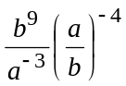and express your answer with positive indices. (3 marks)
__________________________________________________________________________

__________________________________________________________________________

__________________________________________________________________________

__________________________________________________________________________

__________________________________________________________________________

__________________________________________________________________________
Answers written in the margins will not be marked.
Answers written in the margins will not be marked.
Answers written in the margins will not be marked.
__________________________________________________________________________

2. Factorize
(a) 5a² + 4ab – b²,
(b) 5a² + 4ab – b² – 3a – 3b.
(3 marks)
__________________________________________________________________________

__________________________________________________________________________

__________________________________________________________________________

__________________________________________________________________________

__________________________________________________________________________

__________________________________________________________________________

__________________________________________________________________________

__________________________________________________________________________

__________________________________________________________________________

__________________________________________________________________________

__________________________________________________________________________

__________________________________________________________________________

3. Consider the compound inequality
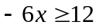 and 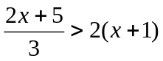 ……(*)
(a) Solve (*).
(b) Write down the greatest negative integer satisfying (*).
(4 marks)
__________________________________________________________________________

__________________________________________________________________________

__________________________________________________________________________

__________________________________________________________________________
Answers written in the margins will not be marked.
Answers written in the margins will not be marked.
Answers written in the margins will not be marked.
__________________________________________________________________________

__________________________________________________________________________

__________________________________________________________________________

__________________________________________________________________________

__________________________________________________________________________

__________________________________________________________________________

__________________________________________________________________________

4. Consider the formula 10(5x – 3y + 4) = 30y. (4 marks)
(a) Make x the subject of the formula above.
(b) It is given that the value of y is increased by 1. How does the value of x change?
__________________________________________________________________________

__________________________________________________________________________

__________________________________________________________________________

__________________________________________________________________________

__________________________________________________________________________

__________________________________________________________________________

__________________________________________________________________________

__________________________________________________________________________
5. The cost of a pen is $25. Suppose the marked price of the pen is 40% above the cost.
(a) Find the marked price of the pen.
(b) If the pen is sold at a discount of 10%, find the selling price. (4 marks)
__________________________________________________________________________
__________________________________________________________________________

__________________________________________________________________________

__________________________________________________________________________

__________________________________________________________________________

__________________________________________________________________________

__________________________________________________________________________
Answers written in the margins will not be marked.
Answers written in the margins will not be marked.
Answers written in the margins will not be marked.

__________________________________________________________________________

__________________________________________________________________________

__________________________________________________________________________

__________________________________________________________________________

6. In a hall, the number of boys is 50 more than the number of girls. After 110 boys entering the hall, the ratio of the number of boys to the number of girls is 5 : 1. Find the original number of boys. (4 marks)
_________________________________________________________________________

_________________________________________________________________________

__________________________________________________________________________

__________________________________________________________________________

__________________________________________________________________________

__________________________________________________________________________

__________________________________________________________________________

__________________________________________________________________________

__________________________________________________________________________

__________________________________________________________________________

__________________________________________________________________________
7. The coordinates of the point P are (3, –1). P is rotated anticlockwise about the origin O
through 90° to P′. Then P′ is translated 6 units to the left and 3 units downwards to P″.
(a) Write down the coordinates of P′ and P″.
(b) Is PP′P″ a right-angled triangle? Explain your answer.
(5 marks)
__________________________________________________________________________

__________________________________________________________________________

__________________________________________________________________________

__________________________________________________________________________

__________________________________________________________________________

__________________________________________________________________________
Answers written in the margins will not be marked.
Answers written in the margins will not be marked.
Answers written in the margins will not be marked.

__________________________________________________________________________

__________________________________________________________________________

__________________________________________________________________________

__________________________________________________________________________

__________________________________________________________________________

__________________________________________________________________________
8. (a) Round up 2867.4403 to 2 decimal places.
(b) Round down 2867.4403 to 3 significant figures.
(c) Round off 2867.4403 to the nearest thousand.

(3 marks)
__________________________________________________________________________

__________________________________________________________________________

__________________________________________________________________________

__________________________________________________________________________

__________________________________________________________________________

__________________________________________________________________________

__________________________________________________________________________

__________________________________________________________________________
9. A letter is selected randomly from each of the two words ‘PRESS’ and ‘EMPLOYEE’. Find the probability of each of the following events. (5 marks)
(a) Both letters selected are ‘E’.
(b) One letter selected is ‘S’ and the other is ‘L’.

__________________________________________________________________________

__________________________________________________________________________

__________________________________________________________________________

__________________________________________________________________________

__________________________________________________________________________

__________________________________________________________________________
Answers written in the margins will not be marked.
Answers written in the margins will not be marked.
Answers written in the margins will not be marked.
__________________________________________________________________________

__________________________________________________________________________

__________________________________________________________________________

__________________________________________________________________________

__________________________________________________________________________

__________________________________________________________________________

__________________________________________________________________________

__________________________________________________________________________

__________________________________________________________________________

__________________________________________________________________________

__________________________________________________________________________

__________________________________________________________________________

__________________________________________________________________________

__________________________________________________________________________

__________________________________________________________________________

__________________________________________________________________________
Answers written in the margins will not be marked.
Answers written in the margins will not be marked.
Answers written in the margins will not be marked.
SECTIONS A(2) (35 marks)
- The x-intercept and the y-intercept of the straight line L: ax + by – 12 = 0 are 6 and 4
respectively, where a and b are constants.
(a) Find the values of a and b. (3 marks)
(b) Find the slope of L. (1 mark)
(c) If the straight line L₁ with y-intercept 8 is perpendicular to L, find the equation of L₁.
(3 marks)
__________________________________________________________________________

__________________________________________________________________________

__________________________________________________________________________

__________________________________________________________________________

__________________________________________________________________________
Answers written in the margins will not be marked.
Answers written in the margins will not be marked.
Answers written in the margins will not be marked.

__________________________________________________________________________

__________________________________________________________________________

__________________________________________________________________________

__________________________________________________________________________

__________________________________________________________________________

__________________________________________________________________________

__________________________________________________________________________

__________________________________________________________________________

__________________________________________________________________________

__________________________________________________________________________

__________________________________________________________________________

__________________________________________________________________________

__________________________________________________________________________

__________________________________________________________________________

__________________________________________________________________________

_________________________________________________________________________

__________________________________________________________________________
11.
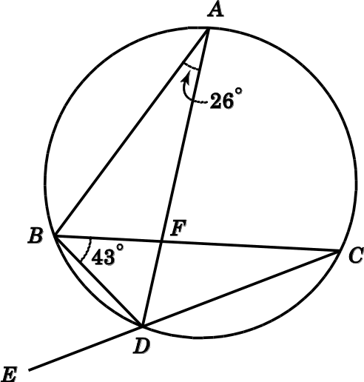
In the figure, AFD, CFB and CDE are straight lines. ∠BAD = 26° and ∠CBD = 43°.
(a) Find ∠BDE. (3 marks)
Answers written in the margins will not be marked.
Answers written in the margins will not be marked.
Answers written in the margins will not be marked.
(b) If AD is a diameter of the circle, find ∠FDC. (3 marks)

__________________________________________________________________________

__________________________________________________________________________

__________________________________________________________________________

__________________________________________________________________________

__________________________________________________________________________

__________________________________________________________________________

__________________________________________________________________________

__________________________________________________________________________

__________________________________________________________________________

__________________________________________________________________________

__________________________________________________________________________

__________________________________________________________________________

__________________________________________________________________________

__________________________________________________________________________

__________________________________________________________________________

__________________________________________________________________________
- Let f (x) = (x + 2)²(x + h) + k, where h and k are constants. When f (x) is divided by x + 1,
the remainder is 6. It is given that f (x) is divisible by x – 1.
(a) Find h and k. (4 marks)
(b) Someone claims that all the roots of the equation f (x) = 0 are rational.
Do you agree? Explain your answer. (3 marks)

__________________________________________________________________________

__________________________________________________________________________

__________________________________________________________________________

__________________________________________________________________________

__________________________________________________________________________
Answers written in the margins will not be marked.
Answers written in the margins will not be marked.
Answers written in the margins will not be marked.
__________________________________________________________________________

__________________________________________________________________________

__________________________________________________________________________

__________________________________________________________________________

__________________________________________________________________________

__________________________________________________________________________

__________________________________________________________________________

__________________________________________________________________________

__________________________________________________________________________

__________________________________________________________________________

__________________________________________________________________________

__________________________________________________________________________

__________________________________________________________________________

__________________________________________________________________________

__________________________________________________________________________

__________________________________________________________________________

__________________________________________________________________________
13.
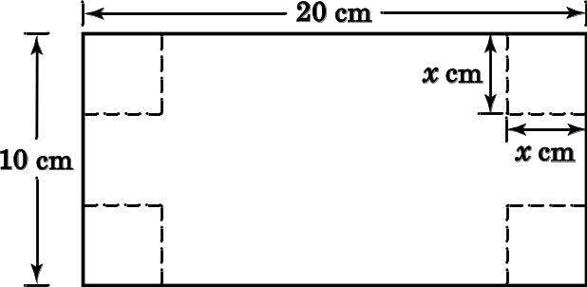
The figure shows a rectangular card with length 20 cm and width 10 cm. A small square of side x cm is cut from each of the four corners of the card. The remaining part of the card is folded to form a rectangular box without a lid. The length of the box is y cm, and its base area is 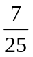 of the area of the original card.
(a) Find the value of x. (5 marks)
(b) Hence, find the capacity of the box. (3 marks)
Answers written in the margins will not be marked.
Answers written in the margins will not be marked.
Answers written in the margins will not be marked.

_________________________________________________________________________________

__________________________________________________________________________

__________________________________________________________________________

__________________________________________________________________________

__________________________________________________________________________

__________________________________________________________________________

__________________________________________________________________________

__________________________________________________________________________

__________________________________________________________________________

__________________________________________________________________________

__________________________________________________________________________

__________________________________________________________________________

__________________________________________________________________________

__________________________________________________________________________

__________________________________________________________________________

__________________________________________________________________________

__________________________________________________________________________

__________________________________________________________________________

__________________________________________________________________________

__________________________________________________________________________

__________________________________________________________________________

__________________________________________________________________________

__________________________________________________________________________

__________________________________________________________________________
Answers written in the margins will not be marked.
Answers written in the margins will not be marked.
Answers written in the margins will not be marked.
__________________________________________________________________________

__________________________________________________________________________

__________________________________________________________________________

__________________________________________________________________________

__________________________________________________________________________

__________________________________________________________________________

__________________________________________________________________________

__________________________________________________________________________

__________________________________________________________________________

__________________________________________________________________________

__________________________________________________________________________

__________________________________________________________________________

__________________________________________________________________________

__________________________________________________________________________

__________________________________________________________________________

__________________________________________________________________________

__________________________________________________________________________
14.
D
A
B
C
Q
P
6 cm
x cm
The figure shows a square ABCD with side 6 cm. P and Q are points on AB and AD respectively such that AP = AQ. Let AP = x cm.
(a) Express the area of △CPQ in terms of x. (2 marks)
(b) The figure below shows the graph of y = 12x − x².
(i) Using the given graph, find the maximum area of △CPQ. (2 marks)
(ii) Using the given graph, find the range of values of x such that the area of △CPQ is greater than 10 cm². (3 marks)
Answers written in the margins will not be marked.
Answers written in the margins will not be marked.
Answers written in the margins will not be marked.
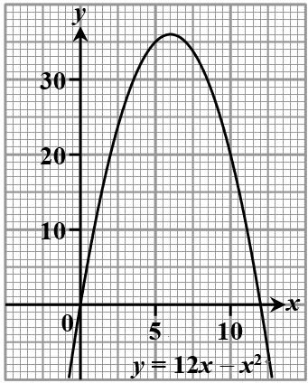

__________________________________________________________________________

__________________________________________________________________________

__________________________________________________________________________

__________________________________________________________________________

__________________________________________________________________________

__________________________________________________________________________

__________________________________________________________________________

__________________________________________________________________________

__________________________________________________________________________

__________________________________________________________________________

__________________________________________________________________________

__________________________________________________________________________

__________________________________________________________________________

__________________________________________________________________________
Answers written in the margins will not be marked.
Answers written in the margins will not be marked.
Answers written in the margins will not be marked.
__________________________________________________________________________

__________________________________________________________________________

__________________________________________________________________________

__________________________________________________________________________

__________________________________________________________________________

__________________________________________________________________________

__________________________________________________________________________

__________________________________________________________________________

__________________________________________________________________________

__________________________________________________________________________

__________________________________________________________________________

__________________________________________________________________________

__________________________________________________________________________

__________________________________________________________________________

__________________________________________________________________________

__________________________________________________________________________

__________________________________________________________________________
SECTION B (35 marks)
15. For 0° ≤ θ ≤ 360°, solve the equation 2 sin² θ + 5 sinθ − 3 = 0.
(4 marks)

__________________________________________________________________________

__________________________________________________________________________

__________________________________________________________________________

__________________________________________________________________________

__________________________________________________________________________

__________________________________________________________________________
Answers written in the margins will not be marked.
Answers written in the margins will not be marked.
Answers written in the margins will not be marked.
__________________________________________________________________________

__________________________________________________________________________

__________________________________________________________________________

__________________________________________________________________________

__________________________________________________________________________

__________________________________________________________________________

__________________________________________________________________________

__________________________________________________________________________

__________________________________________________________________________

__________________________________________________________________________

__________________________________________________________________________

__________________________________________________________________________

__________________________________________________________________________

__________________________________________________________________________

__________________________________________________________________________

__________________________________________________________________________

16. A bag contains 1 red ball, 3 yellow balls and 5 blue balls. Three balls are randomly drawn from
the bag at the same time.
- Find the number of ways that at least one blue ball is drawn. (2 marks)
(b) Find the number of ways that the number of yellow balls drawn is more than the
number of blue balls drawn. (2 marks)

___________________________________________________________________________

__________________________________________________________________________

__________________________________________________________________________

__________________________________________________________________________
Answers written in the margins will not be marked.
Answers written in the margins will not be marked.
Answers written in the margins will not be marked.
_________________________________________________________________________

__________________________________________________________________________

__________________________________________________________________________

__________________________________________________________________________

__________________________________________________________________________

__________________________________________________________________________

__________________________________________________________________________

__________________________________________________________________________

__________________________________________________________________________

__________________________________________________________________________

__________________________________________________________________________

__________________________________________________________________________

__________________________________________________________________________

__________________________________________________________________________

__________________________________________________________________________

__________________________________________________________________________

__________________________________________________________________________
17.
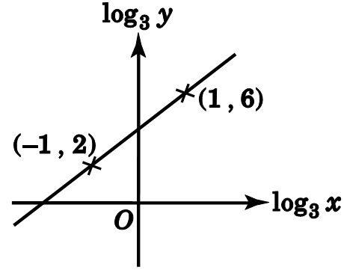
The graph in the figure shows the linear relation between log₃ x and log₃ y. The graph passes through (–1 , 2) and (1 , 6). It is given that y = ax^{b}, where a and b are constants. Find the values of a and b.
(4 marks)
Answers written in the margins will not be marked.
Answers written in the margins will not be marked.
Answers written in the margins will not be marked.
_________________________________________________________________________

__________________________________________________________________________

__________________________________________________________________________

__________________________________________________________________________

__________________________________________________________________________

__________________________________________________________________________

__________________________________________________________________________

_________________________________________________________________________

__________________________________________________________________________

__________________________________________________________________________

__________________________________________________________________________

__________________________________________________________________________

__________________________________________________________________________

_________________________________________________________________________

__________________________________________________________________________

__________________________________________________________________________

__________________________________________________________________________
18. There are 6 boys and 4 girls in the debating team of a school. 4 students are selected
randomly from the debating team to participate in the first round of a debating contest.
(a) Find the probability that 2 boys and 2 girls are selected. (2 marks)
(b) Find the probability that at least 2 boys are selected. (3 marks)

__________________________________________________________________________

__________________________________________________________________________

__________________________________________________________________________

__________________________________________________________________________

__________________________________________________________________________

__________________________________________________________________________
Answers written in the margins will not be marked.
Answers written in the margins will not be marked.
Answers written in the margins will not be marked.

__________________________________________________________________________

__________________________________________________________________________

__________________________________________________________________________

__________________________________________________________________________

__________________________________________________________________________

__________________________________________________________________________

__________________________________________________________________________

__________________________________________________________________________

__________________________________________________________________________

__________________________________________________________________________

__________________________________________________________________________

__________________________________________________________________________

__________________________________________________________________________

__________________________________________________________________________

__________________________________________________________________________

__________________________________________________________________________
19. It is given that k = 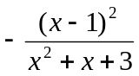, where k ≠ −1.
(a) Show that (k + 1)x² + (k − 2)x + 3k + 1 = 0. (1 mark)
(b) The quadratic equation in x in (a) has two distinct real roots.
(i) Find the range of possible values of k. (5 marks)
(ii) Peter claims that the value of 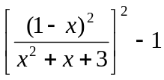 can be greater than 3. Do you agree?
Explain your answer. (3 marks)

__________________________________________________________________________

__________________________________________________________________________

__________________________________________________________________________

__________________________________________________________________________
Answers written in the margins will not be marked.
Answers written in the margins will not be marked.
Answers written in the margins will not be marked.
Answers written in the margins will not be marked.
Answers written in the margins will not be marked.
Answers written in the margins will not be marked.
__________________________________________________________________________

__________________________________________________________________________

__________________________________________________________________________

__________________________________________________________________________

__________________________________________________________________________

__________________________________________________________________________

__________________________________________________________________________

__________________________________________________________________________

__________________________________________________________________________

__________________________________________________________________________

__________________________________________________________________________

__________________________________________________________________________

__________________________________________________________________________

__________________________________________________________________________

__________________________________________________________________________

__________________________________________________________________________

__________________________________________________________________________

__________________________________________________________________________

__________________________________________________________________________

__________________________________________________________________________

__________________________________________________________________________

__________________________________________________________________________

__________________________________________________________________________

__________________________________________________________________________
Answers written in the margins will not be marked.
Answers written in the margins will not be marked.
Answers written in the margins will not be marked.
__________________________________________________________________________

__________________________________________________________________________

__________________________________________________________________________

__________________________________________________________________________

__________________________________________________________________________

__________________________________________________________________________

__________________________________________________________________________

__________________________________________________________________________

__________________________________________________________________________

__________________________________________________________________________

__________________________________________________________________________

__________________________________________________________________________

__________________________________________________________________________

__________________________________________________________________________

__________________________________________________________________________

__________________________________________________________________________

__________________________________________________________________________
20. Let f(x) = −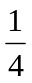x² + 3rx − 10r² − 7, where r is a non-zero constant.
(a) Does the graph of y = f(x) cut the x-axis? Explain your answer. (2 marks)
(b) Using the method of completing the square, express the coordinates of the vertex of the
graph of y = f(x) in terms of r. (3 marks)
(c) Let P and Q be the vertices of the graph of y = f(x) and the graph of y = −f(x) − 4
respectively. Does the perpendicular bisector of PQ pass through the point (0, −1)?
Explain your answer. (4 marks)
__________________________________________________________________________

__________________________________________________________________________

__________________________________________________________________________

__________________________________________________________________________

__________________________________________________________________________
Answers written in the margins will not be marked.
Answers written in the margins will not be marked.
Answers written in the margins will not be marked.

__________________________________________________________________________

__________________________________________________________________________

__________________________________________________________________________

__________________________________________________________________________

__________________________________________________________________________

__________________________________________________________________________

__________________________________________________________________________

___________________________________________________________________________

_________________________________________________________________________

__________________________________________________________________________

__________________________________________________________________________

__________________________________________________________________________

__________________________________________________________________________

__________________________________________________________________________

__________________________________________________________________________

__________________________________________________________________________

_________________________________________________________________________

__________________________________________________________________________

__________________________________________________________________________

__________________________________________________________________________

__________________________________________________________________________

__________________________________________________________________________

__________________________________________________________________________

__________________________________________________________________________

_________________________________________________________________________
Answers written in the margins will not be marked.
Answers written in the margins will not be marked.
Answers written in the margins will not be marked.

__________________________________________________________________________

__________________________________________________________________________

__________________________________________________________________________

__________________________________________________________________________

__________________________________________________________________________

__________________________________________________________________________

__________________________________________________________________________

_________________________________________________________________________

__________________________________________________________________________

__________________________________________________________________________

__________________________________________________________________________

__________________________________________________________________________

__________________________________________________________________________

__________________________________________________________________________

__________________________________________________________________________

END OF PAPER

Answers written in the margins will not be marked.
Answers written in the margins will not be marked.
Answers written in the margins will not be marked.

